ANNEX to the Resolution of the

Central Election Commission of the

Republic of Uzbekistan

No. 1172 dated 28 June 2022

**Regulations on Referendum Precincts and Precinct Referendum Commissions**

These Regulations, in accordance with the Law of the Republic of Uzbekistan “On Referendum of the Republic of Uzbekistan”, shall define the procedure for the establishment of Referendum Precincts, approval of the composition of the Precinct Referendum Commissions (hereinafter referred to as the Precinct Commissions) and the activities of the Precinct Commissions.

**Chapter I. General provisions**

1. Referendum Precincts shall be established by the District Referendum Commissions (hereinafter referred to as the District Commissions) upon the proposal of the khokims of districts and cities.

Referendum Precincts shall be established in military units by the District Commissions as advised by unit commanders or military formations.

The establishment of Referendum Precinct Commissions at diplomatic missions and other representative offices of the Republic of Uzbekistan in foreign countries, the procedure for the establishment of Precinct Commissions, and their other specificities shall be determined by separate regulations to be approved by the Central Election Commission of the Republic of Uzbekistan.

2. Referendum Precincts shall be established no later than the fifteenth day after the publication of the decision on the calling of the referendum.

In military units, remote and inaccessible areas, places of detention and imprisonment, Referendum Precincts shall be established on the same date or, in exceptional cases, not later than five days before the referendum.

3. Referendum Precincts shall normally be established with a number of not less than twenty and not more than three thousand citizens entitled to participate in the referendum.

4. The Precinct Commission shall be established by the District Commission no later than twenty-five days after the publication of the decision on the calling of the referendum, consisting of five to nineteen members, including the Chairperson, the Deputy Chairperson, and the Secretary of the Commission.

If necessary, the number of Precinct Commission members may be increased or decreased.

**Chapter II. Requirements for Precinct Commission members**

5. Members of the Precinct Commission may be citizens over twenty-one years of age, with secondary or higher education, as a rule, with experience in preparing and holding elections and referendums, and with a reputation among the population.

Precinct Commission members shall not be members of other Referendum Commissions, members of political parties, regional, district, and city khokims, officials of the prosecutor's office or courts, or members of citizens' action groups.

6. Persons working in the same organization shall not be recommended as members of the Precinct Commission, if their number is more than half of the members of this Commission, except for the Precinct Commissions established in diplomatic missions and other representative offices of the Republic of Uzbekistan in foreign countries, in military units, sanatoria and recreation centers, hospitals, and other inpatient medical institutions, places of detention and imprisonment.

The following reserves shall be recommended for the establishment of the remaining half of the Precinct Commission:

Citizens with experience in preparing and holding elections and referendums, who are respected by the population;

Representatives of non-governmental non-profit organizations and other civil society institutions;

Persons with legal knowledge and qualifications (legal advisers, lawyers, etc.);

professionals who speak foreign languages.

7. To operate the Information Management System of the Electoral Process (hereinafter referred to as the IMSEP) and the Single Electronic List of Voters (hereinafter referred to as the SELV), it is recommended that each Precinct Commission has at least two persons (main and backup) who have the knowledge and practical skills in information and communication technology.

8. In the composition of Precinct Commissions, in particular leadership positions, attention should be paid to ensuring equal representation of women and men, as well as the inclusion of socially active citizens with disabilities.

**Chapter III. Recommendation of candidates to the Precinct Commission**

9. After publishing the decision on calling the referendum, citizens' self-governing bodies, public associations, enterprises, institutions, and organizations shall form a pool of candidates for the Precinct Commission on their initiative or based on proposals of the district, city Kengashes (Councils) of People's Deputies.

The heads of military units, sanatoriums and recreation centers, hospitals, and other in-patient medical institutions shall recommend candidates for the Precinct Commission members from among their employees for approval by the District Commission no later than twenty days after the publication of the decision on calling the referendum.

10. Once Referendum Precinct Commissions have been established, the pool of candidates for Precinct Commissions shall be discussed by:

Citizens' self-governing bodies - at a citizens' gathering or meeting of citizens' representatives or citizens' gathering;

Public associations, enterprises, institutions, and organizations - at a meeting of labour collectives, and the result of the meeting shall be drawn up in Protocol and submitted for consideration to the district and city Kengashes (Councils of Peoples' Deputies).

11. The district and city Kengashes (Councils) of People's Deputies shall, no later than twenty days after the publication of the decision on calling the referendum, discuss at their meetings, in accordance with the established procedure, the proposals made by citizens' self-governing bodies, public associations, enterprises, institutions, and organizations.

Following the discussion, a decision shall be made to recommend candidates to the Precinct Commission and the resulting list of candidates shall be submitted to the relevant District Commission for approval on the same day.

12. If in military units, as well as in locations of citizens stay in remote and inaccessible areas, in places of detention and imprisonment, Referendum Precincts shall be established at least 5 days before the referendum, a decision to recommend candidates to the Precinct Commission shall be submitted to the District Commissions along with the proposal to establish the Referendum Precincts.

13. The composition of the Precinct Commission shall be approved by a decision of the respective District Commission.

14. The decision of the District Commission on approving the composition of the Precinct Commission shall be published on the official websites of the local public authorities and other sources.

**Chapter IV. Exclusion from or change in the composition of a Precinct Commission**

15. A member of the Precinct Commission shall be excluded from the Commission upon his/her application or upon the decision of the body that approved him/her as a member of the Commission, in the cases of

Election to another Referendum Commission;

Membership in a political party;

Appointment (endorsement) as regional, district, or city khokim;

Appointment (or election) to a responsible post in the procurator's office or court.

A member of the Precinct Commission may be excluded from the Commission in other cases in accordance with the decision of the body that approved him or her as a member of the Commission under an application of own volition.

16. Should a member of the Precinct Commission violate the requirements of the Law “On Referendum of the Republic of Uzbekistan” or systematically ignore his/her duties, he/she may be deprived of his/her authority by a decision of the body that approved him/her as a member of the Commission.

The fact that a member of the Commission violates the requirements of the Law “On Referendum of the Republic of Uzbekistan” or systematically neglects his/her duties shall be documented by an Act of the Commission to which he/she belongs.

17. In cases where a member of the Precinct Commission is excluded from the Commission or the number of members of the Commission is increased, a new member of the Commission shall be elected in accordance with the procedure established by these Regulations.

**Chapter V. Organization of the Precinct Commission's activities**

18. The Chairperson, Deputy Chairperson, Secretary, or another member of the Precinct Commission, upon its decision, may be released from work or official duties during the preparation and holding of the referendum.

19. A member of the Precinct Commission shall not be dismissed or transferred to another job until the end of his/her term of office during the referendum period on the initiative of the employer without his/her consent.

20. The certificate for the Chairperson, Deputy Chairperson, Secretary, and members of the Precinct Commission shall be issued using the pro-forma provided in Annexes 1, 2, 3 or 4 to these Regulations, respectively.

The certificate of the Chairperson of the Precinct Commission shall be signed by the Chairperson of the District Commission and affixed with a stamp of the District Commission.

The certificates of the Deputy Chairperson of the Precinct Commission, Secretary, and members of the Commission shall be signed by the Chairperson of the Precinct Commission and affixed with a stamp of the Precinct Commission.

21. The principles of the Precinct Commission shall be legality, collegiality, publicity, and justice.

22. The organizational form of Precinct Commission's work shall be its sessions which shall be held as necessary.

The session of the Precinct Commission shall have a quorum if not less than two-thirds of the total number of the Commission members as of the day of the session take part in it.

23. Sessions of the Precinct Commission shall be called on the initiative of the Chairperson or request of no less than one-third of the total number of the Commission members.

24. Decisions of the Precinct Commission shall be made by open voting by the majority of votes of the total number of the Commission members. In the event of a tie vote, the Chairperson shall have a casting vote.

25. The Precinct Commission shall operate in an open and transparent manner.

Protocols shall be kept at the meeting to record the agenda, the names and surnames of the members attending the meeting, the results of the vote on each item reviewed and the decisions taken.

A Chairperson and the Secretary shall sign the Protocol. All decisions, findings, and other documents adopted at the meeting, as well as written dissenting opinions of the Commission members on a particular issue, shall be attached to the Protocol.

26. The meetings of the Precinct Commission may be attended by members of superior commissions, observers from political parties, citizens' self-governing bodies, citizens' action groups (hereinafter referred to as the local observers), and representatives of the media, observers from other states and international organizations.

Representatives of local governmental authorities, public associations, and others may be invited to the meetings.

27. Local observers, representatives of the mass media, observers from other states and international organizations shall have the right to participate in all activities of the Precinct Referendum Commission for preparing and holding of the referendum, as well as in the premises for voting on the referendum day and during the vote counting.

Their powers must be confirmed with relevant documents.

**Chapter VI. Powers of the Precinct Commission**

28. Precinct Commission shall:

compile a list of voting citizens for the referendum precinct on the basis of the IMSEP;

introduce voters with a list of voters, accept and consider applications on errors and inaccuracies in the list, and resolve the matter of making appropriate changes to the list;

accept ballots in closed envelopes filled out by voters who are unable to be at their place of residence on election day and participate in voting;

inform the population about election day and voting place;

provide preparation of the premises with booths or rooms for a secret ballot and ballot boxes, as well as other equipment;

organize voting at the Precinct Commission on election day;

consider the appeals of voters and other participants of the election process, and make decisions on them;

arrange for voting to take place at the place of residence of voting citizens at their request if they cannot come to the premises for voting for health or other reasons;

count the votes;

examine and decide on appeals by citizens and other referendum participants;

exercise other powers in accordance with the Law “On the Referendum of the Republic of Uzbekistan” and these Regulations.

29. Chairperson of the Precinct Commission shall:

manage the work of the Precinct Commission;

convene meetings of the Precinct Commission, preside over these meetings, and determine the procedure for holding the meetings;

distribute duties between the Commission members;

represent the Precinct Commission in relations with governmental bodies, international organizations, and public associations;

arrange the proper equipment for the building of the Precinct Commission and the voting room;

sign resolutions of the Precinct Commission, certificates of the Deputy Chairperson of the Precinct Commission, Secretary, and members of the Commission, as well as other documents;

distribute applications from individuals and legal entities among the Commission members for their consideration;

arrange and coordinate verification of the accuracy of the data entered into the list of voting citizens by the Precinct Commission members by door-to-door canvassing of the population;

define the tasks of the Precinct Commission members on the day of voting;

represent the Commission in relations with local observers, mass media representatives, observers from other states, and international organizations;

inform the District Commission or law enforcement agencies if offenses related to the preparation and holding of the referendum are detected;

deposit the documents pertaining to the Commission's activities in the relevant city and district state archives and the city and district khokimiyats after the results of the referendum have been announced;

exercise other powers in accordance with the Law “On referendum of the Republic of Uzbekistan” and these Regulations.

Should the Chairperson of the Precinct Commission be unable to exercise his or her powers, as well as in the absence of the Chairperson, his or her functions shall be assigned to the Deputy Chairperson or a member of the Precinct Commission by decision of the Commission.

30. Deputy Chairperson of the Precinct Commission shall:

coordinate the activities of the Commission members;

arrange professional development for the Precinct Commission members and provide methodological support for their activities;

establish contacts with media representatives and organize comprehensive coverage of the Commission's activities;

organize the registration of local observers, mass media representatives, as well as observers from other states and international organizations following the documents provided by the relevant Referendum Commission;

receive individuals and legal entities, as well as their representatives, and organize the consideration of their appeals in accordance with the established procedure;

together with the members of the Precinct Commission ensure implementation of the Commission's decisions;

execute instructions from the Chairperson of the Precinct Commission;

give instructions to other members of the Precinct Commission within the limits of his or her powers;

perform other duties in accordance with the Law "On referendum of the Republic of Uzbekistan" and these Regulations.

Should the Deputy Chairperson of the Precinct Commission be unable to exercise his/her powers, as well as in case of his/her absence, the functions of the Deputy Chairperson shall be assigned to the Secretary of the Commission or one of its members by the decision of the Precinct Commission.

31. Secretary of the Precinct Commission shall:

organize meetings of the Precinct Commission, prepare draft resolutions and other documents on the issues discussed;

inform members of the Precinct Commission about the time and place of the Commission meeting;

execute the instructions of the Chairperson and Deputy Chairperson of the Commission;

keep documents related to the activities of the Precinct Commission using the nomenclature;

receive the necessary information to access the IMSEP from the Secretary of the District Commission;

upload the list of voting citizens from SELV and submit it to the Chairperson of the Commission;

perform other duties in accordance with the Law “On Referendum of the Republic of Uzbekistan” and these Regulations.

32. A member of the Precinct Commission shall:

perform his/her duties in a timely and qualitative manner according to the functions allocated by the Chairperson of the Precinct Commission, as well as the instructions of the Chairperson and Deputy Chairperson;

take part in the meetings of the Precinct Commission;

ensure in due time consideration of the appeals from individuals and legal entities entrusted to him/her;

ensure timely and qualitative implementation of the tasks defined by the Chairperson of the Precinct Commission on voting day;

In the event of any violations related to the preparation and holding of the referendum, immediately notify the Chairperson or Deputy Chairperson accordingly;

verify the data about a citizen in the list of voting citizens, issue a voting ballot against his/her signature on the basis of an identification document of a voting citizen;

create conditions for observers and representatives of mass media to observe the voting process

perform other powers in accordance with the Law “On Referendum of the Republic of Uzbekistan” and these Regulations.

33. A member of the Precinct Commission shall:

be notified in advance of the meetings of the Commission;

have the right to participate in meetings of the Commission;

make proposals on the issues that fall under the competence of the Commission, and request that the vote be held on the given issue;

have the right to examine the documents of the Commission related to the referendum, and to receive copies of these documents;

vote on the issues discussed at the meeting of the Commission and sign its decisions in accordance with the procedure established by law.

34. Government authorities and bodies of public associations, enterprises, institutions, organizations, and officials shall be obliged to assist Precinct Commissions in exercising their powers and provide information necessary for their work.

35. The Precinct Commission shall have the right to apply to the government authorities and bodies of public associations, enterprises, institutions, organizations, and officials on the issues concerned with preparing and holding the referendum, who shall consider the issue put and provide the answer to the Precinct Commission not later than within three days.

36. The decision of the Precinct Commission, adopted within its competence, shall be binding for all the government authorities, political parties and other public associations, labour collectives, and military units, heads of enterprises, institutions, and organizations.

37. The Precinct Commission shall have a stamp in the form specified in Annex No. 8 to these Regulations.

**Chapter VII. Planning and organization of the Precinct Commission's work**

38. The Precinct Commission, after approval by the District Commission at the first organizational meeting, within one day shall consider the following issues:

approval of the Precinct Commission's work plan for the preparation and holding of the referendum;

distribution of duties among the members of the Precinct Commission;

organization of daily reception of citizens by the members of the Precinct Commission;

organization of duty of Precinct Commission members;

decision-making on the development, approval, and practical application of the record-keeping nomenclature of the Precinct Commission.

39. Shall perform the necessary organizational work to equip in the prescribed manner the building where the Precinct Commission is located.

40. Shall inform the voting citizens about the phone number, office hours of the Precinct Commission, and the place of voting.

41. Shall ensure drawing up lists of voting citizens and presenting them for public scrutiny at least ten days prior to the referendum. This list shall include only the surname, first name, patronymic, and year of birth of voting citizens.

In sanatoriums and recreation centers, in hospitals and other inpatient medical institutions, in remote and hard-to-reach areas, and places of detention and imprisonment, lists of voting citizens shall be submitted for public scrutiny seven days before voting day. This list shall contain only the surname, first name, patronymic, and year of birth of voting citizens.

42. Shall compile a list of first-time voters, sick and elderly citizens, as well as citizens with limited physical abilities and disabled persons, on the territory of the referendum precinct.

43. Shall accept ballots and stencils under the Act from the District Commissions, produced in Braille, as well as ensure storage of the ballots.

44. Shall notify voting citizens of the day, time, and place of voting at least ten days prior to the referendum.

45. Shall endorse the ballots received from the District Commission by signing by two members of the Precinct Commission and affixing the stamp of the Commission, as well as shall ensure their safekeeping.

**Chapter VIII. Decorating the Buildings of Precinct Commissions and Voting**

46. Government authorities, enterprises, institutions, and organizations have an obligation to make available to Precinct Commissions, free of charge, the premises and equipment necessary for the organization and holding of voting in the referendum precincts.

Properly equipped premises for voting shall be provided by khokimiyats of cities and districts to Precinct Commissions not less than eleven days before the referendum.

47. The building where the Precinct Commission is located must be appropriately equipped and shall have the following:

The State Flag of the Republic of Uzbekistan (above the building and indoors);

The State Emblem of the Republic of Uzbekistan (indoors);

A signboard indicating the reference number of the referendum precinct;

bright and spacious premises for voting;

lockable safe or a metal cabinet;

the booths for secret voting equipped with writing materials (for the voters up to 1000 persons - at least 2 pcs, for the voters up to 2000 persons - at least 3 pcs, for the voters up to 3000 persons - at least 4 pcs);

specially equipped booths for the secret voting of voters with physical disabilities;

stationary ballot box;

mobile ballot box;

plastic seals (7 in total, 3 of them for the stationary ballot box, 1 for the mobile ballot box, 1 for the bag, and 2 spare seals);

stamp of the Precinct Commission;

necessary furniture, office equipment (computer, printer, scanner, copying equipment, UPS), telephone, TV;

at least 2 computers that meet the IMSEP requirements and the necessary equipment for it (UPS, printer, scanner, etc.), as well as uninterrupted communication via the Internet;

separate seats for observers;

fire-fighting equipment.

The Precinct Commission building and the paths leading to it must be clean, well-maintained, and well-lit.

The Precinct Commission shall set up a stand in the voting room or directly in front of it, where samples of ballots for voting in the referendum, both for and against the referendum matter, shall be placed, and if a draft law is put to the referendum, the text of the draft law shall be placed on the stand. In case the draft law to be submitted to a referendum envisages repealing the current law or amending or supplementing it, the text of the current law to be repealed, amended, or supplemented shall be placed on the stand.

48. The stands for posting information about the preparation and holding of the referendum shall display:

posters dedicated to the date of the referendum (___ days left before the referendum of the Republic of Uzbekistan);

map of the referendum precinct;

information about the composition, work plan, and duty schedule of the members of the Precinct Commission;

information about the question put to the referendum;

information reflecting the hotline or e-mail address of the Central Election Commission, telephone numbers of the District Commission, the respective district (city) court, and the prosecutor's office for citizens' appeals;

voting procedure;

list of voting citizens;

explanatory materials about the referendum in the form of infographics.

49. On the roads leading to the polling premises, the signs of the referendum precinct shall be placed in visible positions in accordance with the form in Annex No. 9 to these Regulations.

50. A signboard indicating the ordinal number of the referendum precinct in the form specified in Annex No. 10 to these Regulations shall be placed at the entrance to the Precinct Commission premises, walkways for wheelchair access (ramps) that meet the established requirements (width not less than 90 centimeters, angle of entry not more than 300) shall be available.

51. The Precinct Commission shall have the following registers and folders for record keeping:

a folder with the decisions, protocols, and acts of the Precinct Commission;

a register and a folder for registration of incoming and outgoing documents, including appeals;

a log of observers.

**Chapter IX. List of Voting Citizens**

52. The list of voting citizens shall be compiled by the Precinct Commission on the basis of the SELV.

Every voter can be included in only one voter list.

The list of voting citizens shall include all citizens of the Republic of Uzbekistan who have reached the age of eighteen by the day or the day of the referendum and who are permanently or temporarily residing on the territory of the given referendum precinct by the time the list is compiled.

The list of voting citizens shall include the surname, first name, patronymic, date of birth and home address of each voter.

Citizens declared incapable by a court, as well as those held under a court sentence in places of imprisonment for grave and especially grave crimes, shall not be included in the list of voting citizens.

53. The Secretary of the Precinct Commission shall approach the District Commission to get the right of access to the IMSEP. The Secretary of the District Commission shall grant the Secretary of the Precinct Commission the right to access the IMSEP.

The Secretary of the Commission, within three days after the establishment of the Precinct Commission, shall upload the preliminary list of the voting citizens of the given precinct, distributed in the IMSEP, by logging into the information system.

The Secretary of the Commission shall check the list of voting citizens, print it out and present it to the Chairperson of the Precinct Commission.

The Chairperson of the Precinct Commission shall distribute to the members of the Precinct Commission the information about the citizens, included in the list of voting citizens to check information accuracy.

54. Once the Precinct Commission receives the preliminary list of citizens living on the territory of the given referendum precinct, it shall take measures for its clarification.

Khokimiyats, relevant bodies, including gatherings of mahalla citizens, and prevention inspectors shall provide information about citizens residing on the territory of the given referendum precinct within 24 hours upon the request of the Precinct Commission.

Members of the Precinct Commission, if necessary, shall clarify information about the voting citizens living on the territory of the referendum precinct, by door-to-door canvassing.

The Precinct Commission may involve representatives of the public and volunteers to participate in the work of compiling the list of voting citizens. Khokimiyats of districts and cities shall assist in the work on clarification of the lists of voting citizens.

During door-to-door canvassing members of the Precinct Commission shall clarify the facts of the presence of citizens on the territory of the given precinct on the day of the referendum, the errors and inaccuracies in the information about these citizens in the list of voting citizens.

If it is established that there are citizens, temporarily residing on the territory of the referendum precinct, but not included in the list of voting citizens on the given precinct, and during the personal conversation the fact of their presence on the voting day on the given territory of the referendum precinct is established, the application according to the template in the Annex № 11 to the present Regulations shall be accepted at their request.

If a citizen, while getting acquainted with the list of voting citizens, discovers that information about him/her has been erroneously registered or that he/she has been included in the list of voting citizens in the referendum precinct located in a territory other than the place of his/her residence, he/she may come directly to the referendum precinct located in the territory of his/her residence and apply with the abovementioned sample application.

The application of a citizen shall be registered by the Chairperson or the Secretary of the Commission in the register of appeals, then the electronic questionnaire of the specified form in IMSEP shall be filled in and automatically sent to the Republican, regional, or district Working Groups (hereinafter referred to as the Working Group) accordingly to make changes to the list of voting citizens.

The Working Group shall review the electronic questionnaire and make appropriate changes to the list of voting citizens in the IMSEP in accordance with the established procedure.

It is not allowed to change the referendum precinct of a citizen, whose precinct was changed according to his/her application, as well as a citizen who did not apply with the application.

In cases of application rejection, the Precinct Commission shall be obliged to issue a citizen a statement with a justification for the rejection of the application.

55. The grounds for introducing amendments and additions to the list of voting citizens upon the application lodged by a citizen who votes at his/her own will can be:

permanent or temporary residence of a voting citizen in the territory of the respective referendum precinct;

a document confirming that the voter has reached the age of eighteen;

availability of a document confirming the annulment of a court decision on declaring the citizen legally incapable or on release from imprisonment.

56. Lists of voting citizens - military personnel stationed in military units, as well as family members of military personnel and other voting citizens, if they live in areas where military units are located, shall be compiled on the basis of data submitted by commanders of military units.

Servicemen, who live outside of military units, shall be included in the lists of voting citizens according to their place of residence on general grounds.

Lists of voting citizens in referendum precincts formed in sanatoriums and recreation centers, in hospitals and other inpatient medical institutions, and in places of detention and imprisonment shall be compiled on the basis of the data submitted by the heads of the mentioned institutions.

In case of including citizens, who are in sanatoriums, recreation centers, hospitals, and other in-patient medical institutions, as well as in places of confinement, into the list of voters, the Precinct Commission, established in these locations, shall take measures to inform the Precinct Commissions in the location of their permanent or temporary residence about the need to exclude them from the list of voting citizens.

The notified Precinct Commission shall make a note in the list of voting citizens in their referendum precinct that this voting citizen is included in the list of voting citizens of another referendum precinct and in the final protocol he/she shall not be included in the total number of voting citizens of the referendum precinct.

57. In the course of work to clarify the list of voting citizens, citizens shall be explained the possibility of early voting and other rights.

58. Lists of the voting citizens shall be downloaded from IMSEP by the Secretary of the Precinct Commission no later than ten days before the referendum, printed, signed by the Chairperson and the Secretary of the Precinct Commission, approved by the stamp of the Precinct Commission and presented for public scrutiny. This list shall include only the surname, first name, patronymic, and year of birth of the voting citizens.

Five days before the referendum the Precinct Commission can send the electronic questionnaires to the Working Groups to correct the mistakes and address the shortcomings detected even after the submission of the lists of voting citizens for public scrutiny.

The Working Groups shall review the electronic questionnaire on the same day and make a decision in accordance with the established procedure.

The final list of voting citizens in precincts formed in sanatoriums and recreation centers, in hospitals and other in-patient medical institutions, in remote and hard-to-reach areas, in places of detention and imprisonment shall be submitted for public scrutiny three days before the referendum. Only the surname, first name, patronymic and year of birth of voting citizens shall be indicated in this list.

59. Amendments to the list of voting citizens shall be suspended five days before the referendum.

Three days before the referendum the Secretary of the Precinct Commission shall download the last lists of the voting citizens from IMSEP, print them out and present them to the Chairperson of the Precinct Commission.

This list shall be signed by the Chairperson and the Secretary of the Precinct Commission affixed with the stamp of the Precinct Commission and used on the voting day.

60. On the day of voting citizens, who for any reason are absent from the list of voting citizens, shall apply in writing to the Chairperson of the Precinct Commission with a document certifying their identity, citizenship, and place of residence (registration at the place of permanent residence or temporary stay on the territory of the given referendum district).

On the basis of the application, an appropriate inscription shall be made with the name, surname, patronymic, date of birth, and place of residence of a voting citizen. These data shall be confirmed by the signatures of the Chairperson or Secretary of the Precinct Commission and the citizen.

The inclusion of the citizen in the annex to the list of voting citizens shall then be decided in the following sequence of actions:

1st action: the Chairperson of the Precinct Commission shall find the citizen's referendum precinct from the IMSEP;

2-nd action: contact the Chairperson of the Commission of the found referendum precinct by means of communication (telephone). If there is no possibility to contact the Chairperson the relevant Work Group shall be informed about the 3rd and 4th actions;

3rd action: shall determine whether a citizen voted or did not vote at the precinct in question;

4th action: after detecting that the citizen did not vote, the Working Group shall report whether the citizen voted based on the annex to the list of voting citizens (shall notify the Precinct Commission that included the citizen in the list of voting citizens);

5th action: shall include the citizen in the annex to the list of the voting citizens according to Annex No. 12 to the given Regulations and give him/her the bulletin.

The Chairperson of the notified Precinct Commission shall enter information about this citizen's voting at another referendum precinct in the list of voting citizens and shall not add him/her to the total number of voting citizens at the precinct when completing the final protocol.

The inclusion of a citizen in the annex to the list of voting citizens shall be rejected in the following cases:

if a citizen has voted at the referendum precinct in the IMSEP;

if a citizen has applied to the Precinct Commission not at the place of permanent or temporary residence.

In doing so, the Chairperson of the Precinct Commission shall explain the need for a citizen to vote at another referendum precinct at his/her place of permanent or temporary residence.

**Chapter X. Early voting**

61. A voter who is unable to stay at his / her place of residence on Election Day shall have the right to early voting.

62. Early voting begins ten days before the election and ends three days before the election.

63. The time of early voting shall be determined by the Central Election Commission, regional, district, city election commissions and communicated to the voters, observers through the media.

64. The Precinct Commissions shall receive from the District Commissions five percent of the ballot papers and envelopes from the total number of voting citizens in the referendum precinct at least three days before the start of early voting.

65. For early voting, the voter on the basis of an application indicating the reason for absence on the Election Day (vacation, business trip, travel abroad, etc.) shall receive a ballot paper and an envelope from the relevant Precinct Commission.

The Precinct Commission shall not demand additional documents from a voting citizen confirming the reasons for absence on referendum day.

66. In the presence of at least two members of the relevant Precinct Commission, a voting citizen shall sign for receipt of a ballot paper in the extract from the list of voting citizens in the prescribed form according to Annex No. 13 to the present Regulations.

A member of the Precinct Commission must mark a citizen who has voted early on the list of voting citizens on the IMSEP as an early voter.

67. The ballot shall be filled in by the voter in a specially equipped booth or room for a secret ballot by making an independent decision.

The procedure for properly completing the ballot paper by voting citizens shall be reflected on the ballot paper.

The voting citizen shall place the completed ballot paper into the envelope and, having glued it together, close it.

68. A voting citizen shall give a member of the Precinct Commission the completed ballot in a closed envelope.

Two members of the Precinct Commission in the presence of the voting citizen shall check the closure of the envelope and sign the envelope and affix the stamp of the Commission.

The envelope shall be kept in the safe of the relevant Precinct Commission until the end of the voting procedure on referendum day.

**Chapter XI. Tasks of the Precinct Commission on Referendum Day**

69. The building for voting on referendum day shall be opened when at least two-thirds of the members of the Precinct Commission are present.

Local observers, voting citizens, media representatives, observers from other states, and international organizations may be present.

70. The Chairperson or the Deputy Chairperson of the Precinct Commission shall determine the duties of the members of the Commission on the day of voting.

71. The members of the Precinct Commission shall be given out prepared ballots, signed by two members of the Commission and sealed, based on the act, according to the form in Annex No. 14 to these Regulations.

To ensure the streamlined distribution of ballots to voting citizens, each member of the Precinct Commission shall be allocated a list of voting citizens in alphabetical order.

72. On polling day the National Anthem of the Republic of Uzbekistan shall be played at 8.00 a.m. at the referendum precinct.

The Chairperson of the Precinct Commission shall announce the start of voting.

73. The Chairperson of the Precinct Commission, in the presence of the members of the Commission, shall check the emptiness of the ballot boxes and seal them with disposable plastic seals, and an act shall be drawn up in accordance with Annex No. 15 to these Regulations, indicating the numbers of the seals.

74. The Chairperson of the Precinct Commission shall report the number of voting citizens at the referendum precinct, the number of ballots received from the District Commission, as well as the number of early voters.

75. The Chairperson of the Precinct Commission or the Deputy Chairperson shall register local observers, mass media representatives, observers from other states, and international organizations on the basis of a mandate issued by the respective Referendum Commission and their identification document.

The Precinct Commission, after their registration, shall create conditions for the full and unhindered exercise of their powers.

76. The Chairperson, the Deputy Chairperson or the Secretary of the Precinct Commission shall notify the District Commission of the commencement of voting through means of communication.

77. The number of ballot papers provided to voting citizens shall be counted every hour.

78. The Chairperson of the Precinct Commission shall coordinate and control the organization and holding of voting, if necessary assist the members of the Commission, and substitute other members in case of temporary absence.

79. The Precinct Commission shall ensure the issuance of not more than one ballot paper for each citizen, participating in voting, according to the list at the precinct.

No more than one ballot paper shall be issued to each voting citizen. Except when, at the request of a voting citizen, a spoiled ballot paper can be replaced with a new one.

**Chapter XII. Features of the organization and holding of a referendum in places of detention and imprisonment**

80. Referendum precincts shall be established by resolution of the District Commission, based on the proposal of the heads of the places of detention and imprisonment. These referendum precincts shall be part of the referendum districts according to their location.

In some cases, on the basis of a proposal submitted to the relevant District Commission by the administration of the penal settlements, the District Commission may decide to assign voting citizens held in those institutions to a referendum precinct by means of a mobile ballot box for voting at the place of detention.

81. Candidates for members of the Precinct Commission shall be recommended by the head of the places of detention and imprisonment from among the staff of the institution for approval by the District Commission.

If necessary, in accordance with Article 23 of Law “On Referendum of the Republic of Uzbekistan”, the head of places of detention and imprisonment may also recommend other persons and representatives of the public as candidates for the Precinct Commission.

82. The list of voting citizens of Referendum Precincts formed in places of detention and imprisonment shall include detainees in places of detention and prisoners held in places of imprisonment under a court sentence for crimes that are not of great public danger and less grave crimes.

83. Lists of voting citizens in the Referendum Precincts established in the places of detention and imprisonment shall be formed by the Precinct Commission on the basis of the data provided by the heads of these institutions.

84. The Ministry of the Interior of the Republic of Uzbekistan shall submit to the State Personalization Centre under the Cabinet of Ministers of the Republic of Uzbekistan information on voting citizens in referendum precincts formed in places of detention and imprisonment at least one month before voting to introduce amendments to the Single Electronic List of Voters.

When the list of voting citizens in the Referendum Precincts formed in these institutions is amended, measures shall be taken at least five days before voting to provide the data to the State Personalization Centre under the Cabinet of Ministers of the Republic of Uzbekistan.

85. In cases where referendum precincts have not been established in penal settlements, the management of the penal establishments concerned shall provide information on the voting citizens of the establishment at least seven days before the vote, to the Precinct Commission assigned to the penal settlements.

86. Observers, accredited representatives of mass media shall inform the Precinct Commission at least three days in advance of their arrival at the referendum precincts formed in the places of detention and imprisonment.

87. In its turn, the Precinct Commission shall provide the administration of the places of detention and imprisonment with information about the persons mentioned in paragraph 86 of these Regulations (name, surname, patronymic, date of birth, in what capacity they participate in the elections), to ensure unimpeded access.

The administration of places of detention and imprisonment shall be responsible for ensuring these persons' access and safety and for observing the internal rules of procedure.

88. Subject to the internal rules and regulations of places of detention and imprisonment, voting citizens shall be taken to the premises for voting in small groups.

In penal settlements where no referendum precinct has been established, the assigned Precinct Commission shall organize voting at the place of stay of voting citizens.

The assigned Precinct Commission shall include these citizens in an annex to the list of voting citizens.

**Chapter XIII. Organization of voting**

89. Voting shall be held on referendum day from 8 a.m. to 8 p.m.

90. Upon arrival at the precinct a voting citizen shall show to a member of the Precinct Commission an identification document (passport, ID card, military ID card, national driving license of new standard, temporary certificate on loss of civil passport issued to a citizen by internal affairs bodies, certificate of departure or release from punishment), and shall sign on the list of voting citizens. After that, s/he shall be given a ballot paper.

It shall be forbidden to give the ballot paper to a citizen who wants to vote for another person.

When filling in the ballot, at the request of the voting citizen, a stencil in Braille shall be provided.

91. The voting citizen, upon receipt of the ballot, shall fill in the ballot in the voting booth or secret voting room.

It shall be forbidden to take photos or videos of the process of filling in the ballot of a voting citizen, and its distribution, including posting on social media.

92. When filling out the ballot, no persons other than the voter shall be present there.

The procedure of correctly filling in the ballot by voting citizens shall be reflected in the ballot.

93. A voting citizen who is not able to fill in the ballot by him/herself shall have the right to invite another person at his/her own discretion to the booth or the room for secret voting, except for the persons who are members of the Precinct Commission, observers and representatives of the mass media.

94. A citizen shall put the completed ballot paper into the ballot box. The ballot boxes shall be visible to the members of the Precinct Commission and observers.

At the request of a citizen, a spoiled ballot paper can be replaced with a new one. Spoiled ballots for voting shall be accounted for, canceled, and kept separately.

95. In the building of the Precinct Commission on the day of the referendum the following persons may be present during the voting

relevant members of the Precinct Commission;

relevant members of the district commission;

members of the Central Election Commission;

local observers;

media representatives;

observers from other states and international organizations;

citizens who participate in voting according to the list of voters at the referendum precinct.

When voting in the building of the Precinct Commission other persons than those who are allowed to be present shall not be allowed to be present. The Precinct Commission shall be responsible for maintaining this necessary order in the building.

Persons who are allowed to be in the building of the Precinct Commission (with the exception of citizens who vote) shall have a mandate (certificate), confirming the status given by the respective Commission, in a place visible to other persons.

The Precinct Commission shall take measures to remove a citizen who has voted from the building.

96. If a member of the Precinct Commission, observers or media representatives violate the secret ballot or try to influence the will of the citizens, the member of the Precinct Commission shall be suspended, and the observers, representatives of the media shall be removed from the voting premises without any delay. This decision shall be taken by the Precinct Commission.

97. The Chairperson of the Commission may call upon officers of internal affairs or the National Guard to ensure silence and order in the voting premises in case of any illegal actions that hinder voting and counting of the votes. In this case, the officers of internal affairs or the National Guard must immediately arrive at the place of the event.

After they have eliminated disturbances and illegal actions on the territory of the referendum precinct, the officers of internal affairs or the National Guard shall leave the building of the referendum precinct and shall be placed in a place that does not interfere with the voting process, as instructed by the Chairperson of the Precinct Commission.

**Chapter XIV. Organization of voting at the voter's place of stay**

98. In cases where individual citizens who vote are unable to come to the polling station for health or other reasons, the relevant Precinct Commission, at their written or verbal request, shall organize voting on referendum day or before referendum day at the place of stay of these voting citizens.

In this case, a member of the Precinct Commission shall enter into the register of appeals a record about the name, first name, patronymic, place of residence of a voting citizen, and time of appeal, and these data shall be certified by the signature of the member of the Precinct Commission.

99. The Precinct Commission shall organize voting at the place of a citizen's stay, considering the workload and circumstances on the day of the referendum.

Members of the Precinct Commission traveling following the appeals of citizens shall sign the number of ballots, equal to the number of appeals. The number of citizens' appeals, as well as the number of used and returned ballot papers, shall be recorded in a separate Act as per the form in Annex No.16 to these Regulations.

100. At least two members of the Precinct Commission shall be sent to the place where a citizen is voting with a mobile ballot box, and shall ensure that the secrecy of the will is respected. Observers and mass media representatives may be present.

101. Information about the citizens, who voted at the place of their stay, shall be entered by the member of the Precinct Commission into the excerpt from the list of the citizens using the form in Annex No.17 to the present Regulations, and the voter shall put his/her signature opposite his/her name in this list, confirming the fact of receiving the bulletin.

102. Once a citizen votes in secret, the entry “voted at the place of stay” shall be made in the corresponding place in the list of voting citizens (opposite the name of the citizen who votes).

**Chapter XV. Determining the voting results**

103. The Chairperson of the Precinct Commission or the Deputy Chairperson shall announce the end of voting at 8 p.m.

Voting citizens present in the building of the referendum precinct shall be given an opportunity to finish voting (if there are voting citizens).

104. At the Referendum Precincts formed in military units, in sanatoria, recreation centers, hospitals, and other in-patient medical institutions, in places of citizen's stay located in remote and hard-to-reach areas, in places of detention and imprisonment, the Precinct Commission may declare the voting closed at any time if all the citizens included in the list have voted.

It shall not be allowed to count the votes and open the ballot boxes before 8 p.m. at the referendum precincts located on the territory of the Republic of Uzbekistan.

105. The counting of votes of those who have voted shall be done by the members of the Precinct Commission according to the ballot papers in the ballot boxes. The votes of the voting citizens shall be counted only in the building for voting.

106. The following persons may be present during the vote counting at the Precinct Commission and in the process of completing the protocols about the results of the vote counting:

local observers;

mass media representatives;

observers from other states and international organizations.

Other persons, except for those, who are allowed to be present, shall be prohibited to be present in the building of the Precinct Commission during the said process.

107. The results of vote counting at the Referendum Precinct shall be formalized by the protocol of the Precinct Commission on the results of vote counting at the referendum precinct using the form in Annex No. 18 to the present Regulations.

108. After the voting is over, the members of the Precinct Commission, in the sequence of actions defined by the legislation, shall perform the following tasks:

1st action: Before the counting begins, the tables shall be grouped together and all writing utensils (pens, pencils, and other tools) shall be set aside with everyone's attention;

2nd action: the number of ballots received from the District Commissions shall be determined and entered into the final protocol;

3rd action: unused and spoiled ballots shall be counted and canceled by cutting the upper left corner or putting the corresponding mark on the back of the ballot, and the respective record shall be made in the final protocol;

4th action: the total number of the voting citizens of the precinct shall be defined according to the list of the voting citizens (except for the data about those who voted at another referendum precinct) and the annex to this list and shall be inserted into the final protocol;

5th action: before opening the stationary and mobile ballot boxes, members of the Commission shall enter the information about the total number of persons who received the ballots on each page of the list of voters and the annex to the list of voters;

after entering the information, each page of the list of voters and the annex to the list of voters shall be signed by the member of the Commission, who entered the information, and the figures in the pages shall be summarized;

the Chairperson of the Commission shall announce the generalized final information about all the pages of the list of voters, add it to the last page of the list of voters, certify it by his/her signature and the stamp of the Precinct Commission, and these data shall be entered to the final protocol;

6th action: the numbers of the seals in the ballot boxes shall be compared with the Act of sealing.

At the referendum precincts established at diplomatic missions and other representative offices of the Republic of Uzbekistan abroad, the numbers on plastic disposable seals in special bags (bag) shall also be compared with the numbers in the relevant Act;

7th action: they put closed envelopes with early voting ballots into the ballot box;

8th act: stationary and mobile ballot boxes (at referendum precincts set up at diplomatic missions and other representative offices of the Republic of Uzbekistan abroad, also special bags) shall be opened. Ballot papers shall be piled on the table and the number of citizens, who took part in voting (ballot papers in ballot boxes) shall be determined, these data shall be entered into the final protocol;

9th action: they distribute the votes “for” and “against” the question put forth in the referendum into separate piles by voicing and showing the ballots.

If there is any doubt about the authenticity of the ballot, the issue shall be resolved by putting it up for a vote by the Precinct Commission. If the decision about the invalidation of the bulletin is made, the Precinct Commission shall indicate the reasons for invalidation on the reverse side of the bulletin. This record shall be confirmed by the signatures of at least three members of the Precinct Commission.

10th action: the votes “for” and “against” a question put for a referendum shall be placed in separate piles for counting and entered into the final protocol;

The “for” and “against” votes on the referendum question shall be bundled in separate stacks. The number of votes shall be indicated on the stack.

11th action: the following ballots shall be declared invalid during the counting of votes:

not corresponding to the form (size, color, quality of paper, typography, and other differences);

ballots, not approved by the Precinct Commission;

bulletins with additional inscriptions or signs.

These ballots recognized as invalid, shall be counted, and bundled into separate stacks and their number shall be entered into the final Protocol.

109. After the necessary actions have been taken, a final meeting of the Commission shall be held where complaints and allegations of offenses committed during the voting and counting of votes shall be examined.

110. Before the Protocol about the results of the vote counting is drafted, the Chairperson of the Commission shall inform those present about the complaints (allegations), received by the Commission on the day of voting and before the vote counting is completed, and about the decisions made on them, show the acts and other documents attached to the Protocol, find out about the claims and complaints about the Commission's activity, if necessary, the Commission shall consider the comments and complaints and take the decisions.

111. The Precinct Commission shall decide on the approval of the Protocol on the results of the vote counting at the referendum precinct.

The Protocol on the results of vote counting shall be made in two copies, signed and sealed by the Chairperson, the Deputy Chairperson, the Secretary, and other members of the Commission.

No changes to the Protocol on the results of vote counting at the Referendum Precinct of the Precinct Commission shall be allowed.

If during the drafting of the Protocol on the results of vote counting at the Referendum Precinct of the Precinct Commission, some members of the Commission are absent, the reasons for their absence shall be indicated in the Protocol.

After that, the Protocol on the results of vote counting at the Referendum Precinct of the Precinct Commission shall be announced by the head of the Precinct Commission or the Deputy Chairperson, and a copy of the extract from the Protocol shall be immediately posted on the building of the Precinct Commission for no less than forty-eight hours, for public scrutiny.

Observers, who participated in the vote-counting process, shall have the right to ask for the approved copy of the extract from the Protocol of the Precinct Commission.

112. A member of the Commission, who does not agree with the content of the Protocol, shall have the right to attach his/her dissenting opinion to the Protocol during the signing of the Protocol on the results of vote counting at the Referendum Precinct of the Precinct Commission, and it shall be recorded in the Protocol.

113. A copy of the Protocol on the results of vote counting at the referendum precinct of the Precinct Commission shall be immediately submitted to the corresponding District Commission with the help of information and communication technologies, while the original shall be delivered to the District Commission by the Chairperson or the Deputy Chairperson, accompanied by the employees of the internal affairs agencies.

If the District Commission detects incorrect completion of the Protocol on the results of the vote counting at the Referendum Precinct of the Precinct Commission or arithmetical errors, the Precinct Commission shall hold an additional meeting and shall correct the mistakes. With the indication of the grounds, the decision on annulment of the previous Protocol shall be adopted, and the corrected Protocol shall be approved by the new resolution. The Protocol posted for public scrutiny shall be replaced by the updated one and sent to the District Commission.

114. The Deputy Chairperson and the Secretary of the Precinct Commission shall write down the number of “for” and “against” votes on the stacks of voted ballots and put the stacks in a bag in order.

After that, they put an “invalid ballots” sign on the stacks of ballots and indicate their number, and put them into a bag.

Then the annulled unused and spoiled ballots shall be tied up and “Annulled unused and spoiled ballots” shall be written on them indicating their number and they shall be put into the bag.

After the ballots are placed in the bag, they also shall put the second Protocol on the list of the voting citizens and the vote count and the documents attached to it.

The bag shall be sealed with a seal and an Act on Sealing the bag shall be drawn up. Following this, the bag shall be put into a safe, sealed, and signed by the Chairperson of the Precinct Commission.

**Chapter XVI. Examination of appeals from individuals and legal entities**

115. Local observers, voting citizens, and other participants of the referendum (hereinafter referred to as the applicants) directly themselves or through their representatives may apply to Precinct Commissions with appeals, proposals, and complaints.

Appeals may be submitted orally, in writing, or electronically.

Appeals, regardless of their form and type, shall have equal value.

116. Appeals of an individual shall indicate the surname, name, patronymic of the individual, and information on her/his place of residence.

The address of a legal entity shall specify the full name of the legal entity, and information on its location (postal address).

The appeal of an individual or a legal entity shall specify the ordinal number of the Precinct Commission, position, and (or) full name of the official to whom the appeal is addressed, as well as the gist of the appeal.

Appeals may contain an e-mail address and contact telephone number.

Appeals may be filed in the official state language and other languages.

117. Applicants shall be guaranteed the right to file individual or collective appeals to Precinct Commissions.

118. The right to appeal shall be implemented voluntarily. No one can be forced to participate in actions in defense of or against any appeal.

The exercise of the right to appeal shall not violate the rights, freedoms, and legitimate interests of other individuals and legal entities, as well as the interests of society and the state.

119. No information about the individual shall be subject to disclosure without the written consent of the applicant.

120. Appeals received from individuals and legal entities shall be distributed by the Chairperson of the Precinct Commission for examination by its members.

The Precinct Commission within the limits of its powers shall examine appeals of individuals and legal entities on violation of the requirements of the Law “On Referendum of the Republic of Uzbekistan” or other issues of the organization of the referendum.

In the process of examining appeals, inspections may be carried out.

Written replies shall be provided within three days, and in respect of appeals received less than six days before the referendum or on the day of voting - immediately.

If the issues raised in the appeal have found a positive solution on the spot, with the consent of the applicant a written response may be not provided.

121. Appeals shall be registered in the registration book.

Refusal to accept and register an appeal shall not be allowed.

To examine the appeal and make a decision on it the Chairperson of the Precinct Commission shall convene the Commission and hold its meeting. Interested parties may be invited to the meeting.

In the case of unlawful refusal to accept or consider the appeal, or if the applicant is dissatisfied with the result of examining the appeal, s/he may appeal in court.

122. An appeal submitted to the Precinct Commission with no powers to resolve the issues raised shall be referred within three days to the relevant authorities with a notification about this to the person who filed the appeal.

123. The following appeals shall not be subject to examination:

anonymous appeals;

appeals filed through representatives of individuals and legal entities in the absence of documents confirming their powers;

appeals not meeting other requirements set by the law.

When leaving appeals without consideration an opinion shall be drawn up, which shall be approved by the Chairperson or Deputy Chairperson of the Precinct Commission.

The appeals left without consideration due to the absence of documents confirming the powers of the applicant's representative shall be notified to the applicant accordingly.

124. Persecution of the applicant, his or her representative, and members of their families in connection with their appeals to government agencies, referendum commissions, and their officials to implement or protect their rights, freedoms, and legitimate interests, as well as expressing their opinions and criticism in their appeals, shall be prohibited.

Persecution of applicants shall entail liability under the procedure established by law.

125. Members of the Precinct Commissions that have considered an appeal shall be obliged to inform the person who submitted it about the time, the results of the examination, and the decision made.

126. The applicants may appeal against the decisions of the Precinct Commissions on the results of examining appeals, as well as other decisions in court within five days after those decisions have been made.

127. The court decision shall be delivered to the relevant Precinct Commission and the applicants immediately after its ruling.

**Chapter XVII. Liability for violation of the referendum legislation**

128. Persons guilty of violating the legislation on election shall be held liable in accordance with the established procedure.

129. Registration of administrative case management of Offenses in the field of Organizing and Holding Elections and Referendums shall be carried out on the basis of the Instruction on the Registration of Cases of Offenses in the field of Organizing and Holding Elections and Referendums by Election Commissions and Referendum Commissions approved by Resolution of the Central Election Commission dated September 11, 2019, No. 934.

**Chapter XVIII. Safekeeping of documents, seals and ballot boxes of the Precinct Commission**

130. Documents related to the preparation and holding of the referendum shall be prepared and handed over for safekeeping in accordance with the Instruction on the Procedure for Safekeeping, Transfer to Archives, and Destruction of Documents related to the Preparation and Holding of Elections and Referendum approved by the Resolution of the Central Election Commission of the Republic of Uzbekistan No. 939 dated September 19, 2019.

131. Tangible assets, such as the seal of the Commission, ballot boxes, booths for secret voting, State Emblem, and Flag, used during the referendum by the Precinct Commission, shall be handed over in the prescribed manner to the responsible persons of organizational-control groups of district and city khokimiyats on the basis of an Act and shall be kept under their responsibility.

**Chapter XIX. Final Provisions**

132. Once the ballots are received, the National Guard security units or internal affairs officers shall secure the building where the ballots and other documents are stored.

133. Precinct Commissions shall cease their activity after the official announcement of the results of the referendum.

ANNEX №1. to the Regulations on Referendum Precincts and Precinct Referendum Commissions

|  |
| --- |
| **CERTIFICATE OF AUTHORIZATION**  ______________________________________  *(surname, first name, patronymic)*  **CHAIRPERSON**  **of the Precinct Referendum Commission №____**  **____- ___________________ of Referendum District**  Photo  **CHAIRPERSON**  **of the District Referendum Commission**  _______ _______________________  *(signature) (last name and initials)*  «_____» ____________________________20__  *(date of the Resolution) Stamp*  Valid only when providing a personal identification document |

ANNEX №2 to the Regulations on Referendum Precincts and Precinct Referendum Commissions

|  |
| --- |
| **CERTIFICATE OF AUTHORIZATION**  ______________________________________  *(surname, first name, patronymic)*  **DEPUTY CHAIRPERSON**  **of the Precinct Referendum Commission №____**  **____- ___________________ of Referendum District**  **Chairperson**  Photo  **of the Precinct Referendum Commission**  _______ _______________________  *(signature) (last name and initials)*  «_____» ____________________________20__  *(date of the Resolution)* Stamp  Valid only when providing a personal identification document |

ANNEX №3 to the Regulations on Referendum Precincts and Precinct Referendum Commissions

|  |
| --- |
| **CERTIFICATE OF AUTHORIZATION**  ______________________________________  *(surname, first name, patronymic)*  **SECRETARY**  **of the Precinct Referendum Commission №____**  **____- ___________________ of Referendum District**  **Chairperson**  Photo  **of the Precinct Referendum Commission**  _______ _______________________  *(signature) (last name and initials)*  «_____» ____________________________20__  *(date of the Resolution)* Stamp  Valid only when providing a personal identification document |

ANNEX №4

to the Regulations on Referendum Precincts and Precinct Referendum Commissions

|  |
| --- |
| **CERTIFICATE OF AUTHORIZATION**  ______________________________________  *(surname, first name, patronymic)*  **MEMBER**  **of the Precinct Referendum Commission №____**  **____- ___________________ of Referendum District**  **Chairperson**  Photo  **of the Precinct Referendum Commission**    _______ _______________________  *(signature) (last name and initials)*  «_____» ____________________________20__  *(date of the Resolution)* Stamp  Valid only when providing a personal identification document |

ANNEX №5

to the Regulations on Referendum Precincts and Precinct Referendum Commissions

**SAMPLE STATIONARY BALLOT BOXES**

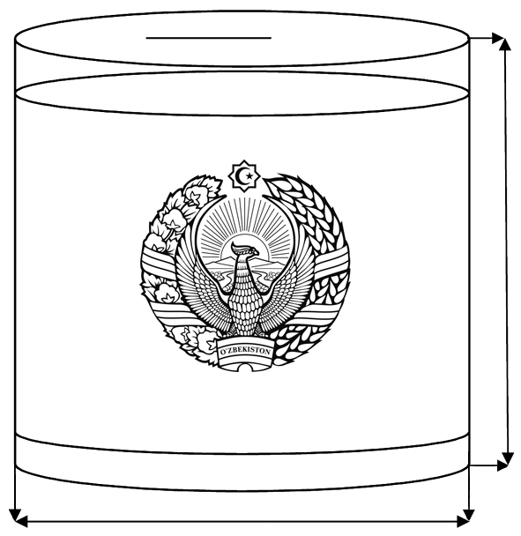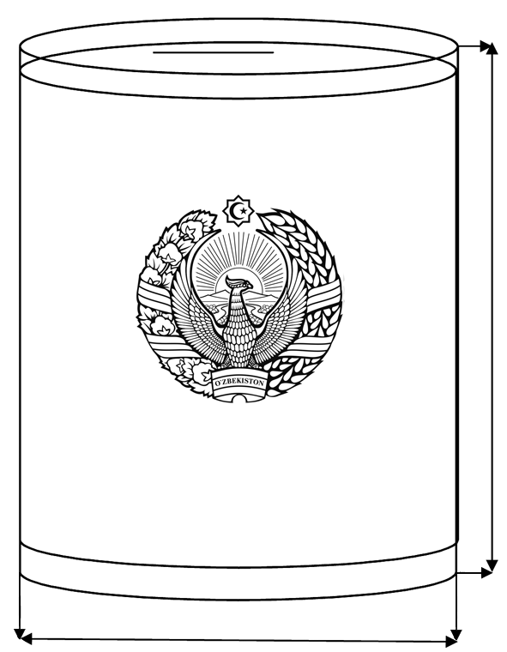100 cm 50 cm

2)

1)

60 cm 60 cm

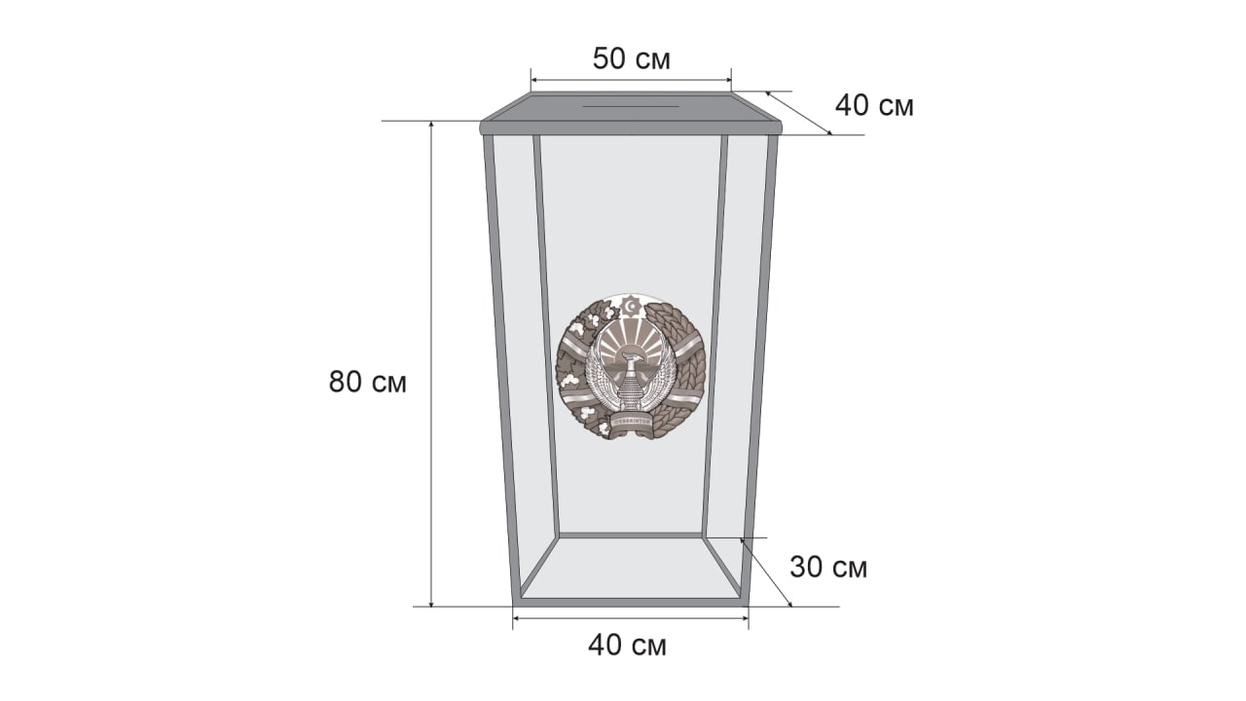

50 cm

cm

cm

cm

cm

3)

**MOBILE BALLOT BOXES**

1) 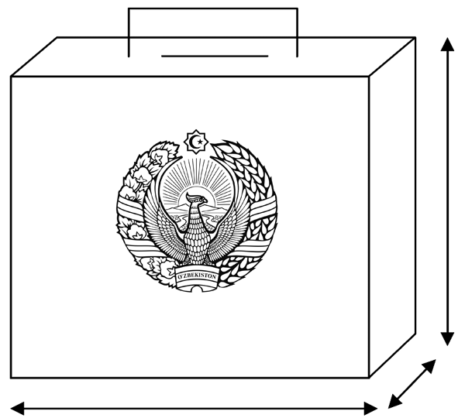35 cm

20 cm

30 cm

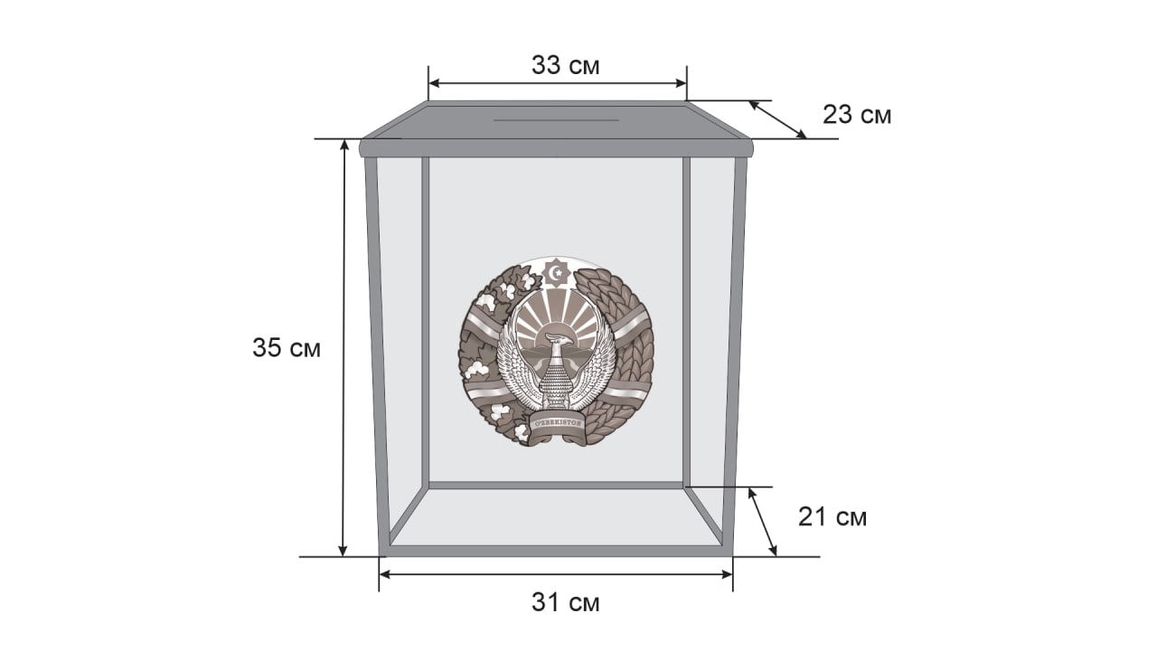

33 cm

cm

2)

35 cm

cm

31 cm

Mobile ballot boxes are intended for voting outside the premises.

The number of ballot boxes for mobile voting shall be determined by the decision of the relevant Precinct Commission, and each of them shall be marked with its ordinal number.

The ballot boxes must be visible to the members of the Precinct Commission and observers from the time they are sealed until they are opened.

A member of the Precinct Commission shall be responsible for monitoring the integrity of the ballot boxes, as determined by the decision of the Commission.

ANNEX №6

to the Regulations on Referendum Precincts and Precinct Referendum Commissions

**A SECRET BALLOT ROOM WITH A LARGE AREA**

**INFORMATION STAND**

**Booth for secret balloting**

**Observers, media representatives**





**EX**

**I**

**T**

К

**ENTRANCE**

В













**LIST OF VOTERS**

###### Distribution of ballot papers

**PRECINCT COMMISSION MEMBERS**

**A SECRET BALLOT ROOM WITH A SMALL AREA**

**INFORMATION STAND**

**АХБОРОТ СТЕНДИ**

Observers, media representatives

**Booth for secret balloting**

ЯШИРИН ОВОЗ БЕРИШ КАБИНАСИ

**ENTRANCE**

**EXIT**

**Stationary**

**ballot**

**box**

**LIST OF VOTERS**

###### Distribution of ballot papers

PRECINCT COMMISSION MEMBERS

ANNEX №7

to the Regulations on Referendum Precincts and Precinct Referendum Commissions

**SKETCH OF THE BoothS for secret balloting**

The booth for secret balloting forms an isolated area that excludes the possibility of control of the voting citizen by those present in the voting room and ensures the secrecy of the vote.

The height of the booth is 2 meters and the width is 0.75 meters. 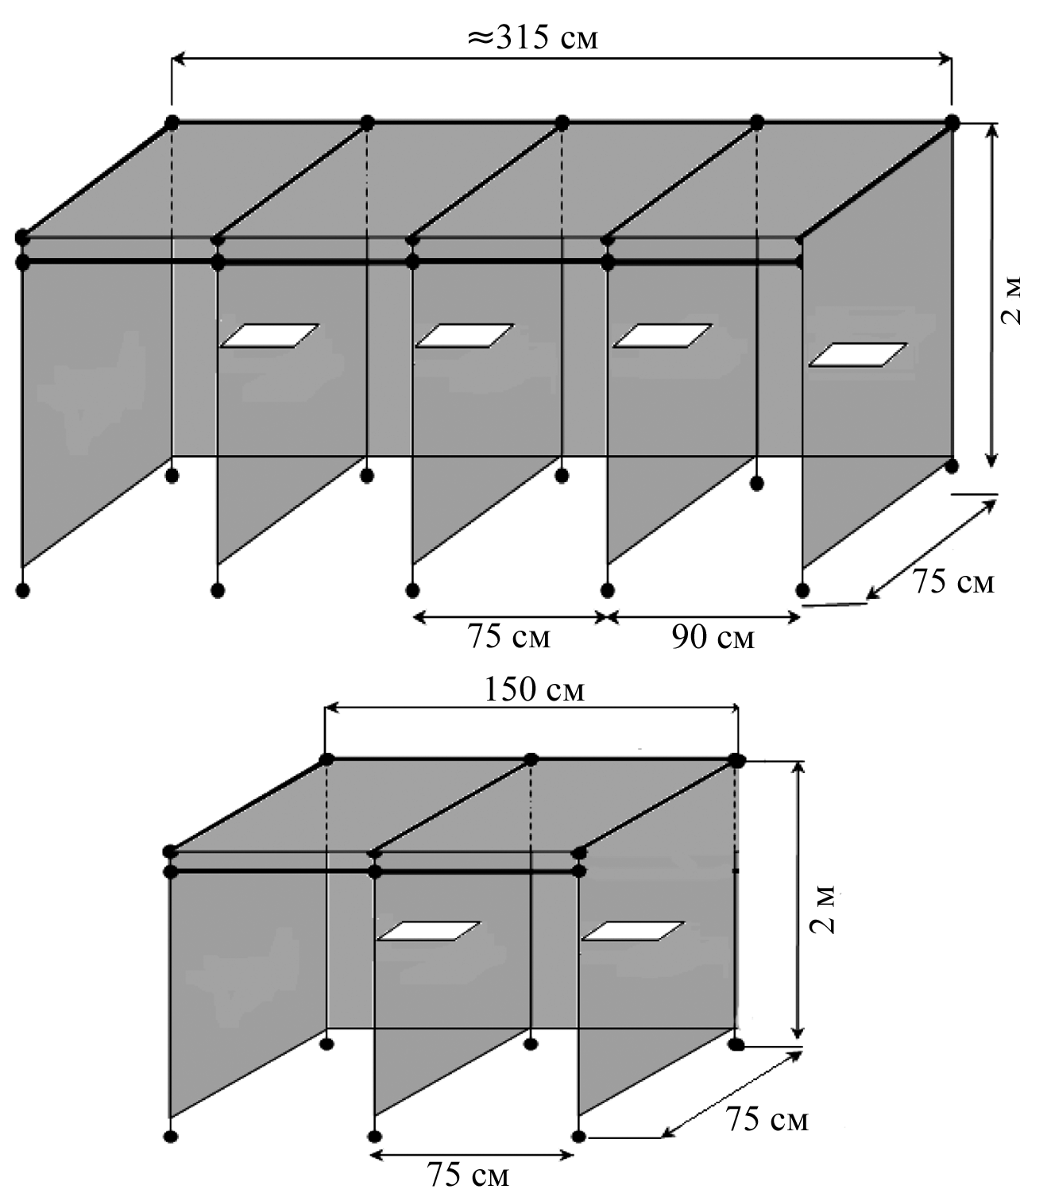

2 m

2 m

75 cm 90 cm

150 cm

75 cm

75 cm

75 cm

315 cm

**MOBILE VOTING BOOTH**

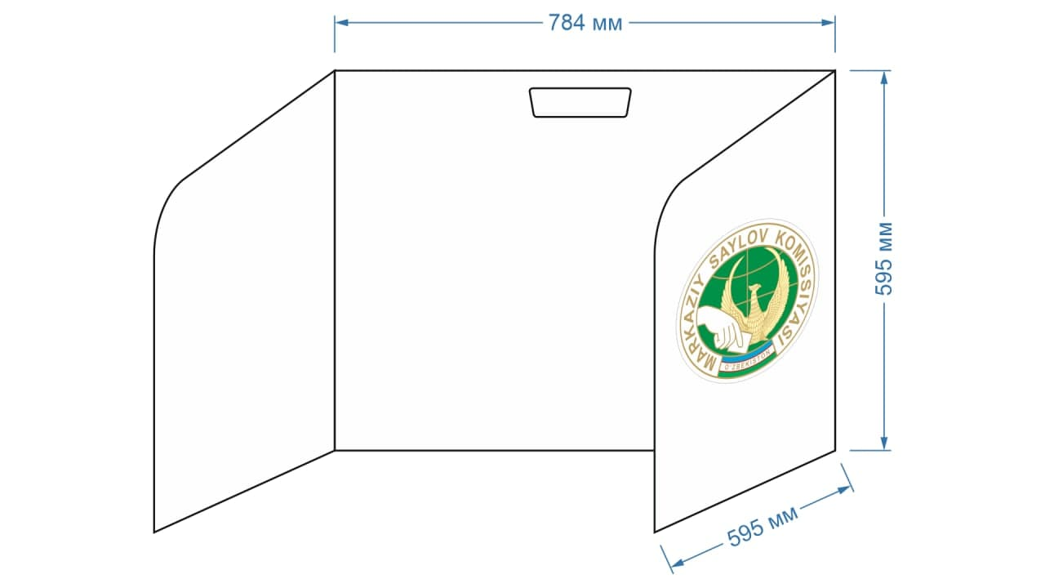

595 mm

595 mm

784 mm

ANNEX №8

to the Regulations on Referendum Precincts and Precinct Referendum Commissions

**Sample of the official rubber stamp of the Precinct Referendum Commission**

**д-35 мм**

**\***

**REFERENDUM O΄TKAZUVCHI** **UCHASTKA KOMISSIYASI**

**\***

**T O SH K E N T SH A H A R**

**242**

**D-35mm**

The rubber stamp of the Precinct Referendum Commission shall be in the form of a circle with a diameter of 35 mm, the main circle at a distance of 17.5 mm from the center, and another circle at a distance of 1 mm. At the bottom of the second circle, there shall be an inscription “Referendum o΄tkazuvchi uchastka komissiyasi*”*, below this inscription in a circle it shall say “Toshkent shahar*”*. At the bottom of this text, there shall be another inner circle at a distance of 0.8 mm from the center. Inside the circle, there shall be the ordinal number of the Precinct Referendum Commission.

*\* The ordinal number of the Precinct Referendum Commission shall be approved by the relevant District Referendum Commission.*

ANNEX №9

to the Regulations on Referendum Precincts and Precinct Referendum Commissions

**Referendum Precinct signage**

**REFERENDUM PRECINCT № 254**

25 cm

75 cm

ANNEX №10

to the Regulations on Referendum Precincts and Precinct Referendum Commissions

**Referendum precinct signboard**

**REFERENDUM PRECINCT № 254**

60 cm

100 cm

ANNEX №11

to the Regulations on Referendum Precincts and Precinct Referendum Commissions

**APPLICATION**

For the purpose of ensuring my right to vote in the referendum, I would like to request that I be added to the list of voting citizens in Referendum Precinct No. _____ at my residential address.

**My personal details:**

|  |  |  |  |  |
| --- | --- | --- | --- | --- |
| **Full name** | **Year, month and date of birth** | **Passport (or ID card) series and number** | **Residential address** | **Telephone number** |
|  |  |  |  |  |

**Citizen** _____________________ ________________________________

*Signature full name*

**Precinct Commission member** _________ ________________________________

*Signature full name*

* This application shall be registered in the appeals register by the Chairperson or Secretary of the Commission. The electronic questionnaire shall be then completed using the form indicated in the IMSEP, which shall automatically be sent to the relevant Working Group of the republic, region, or district to amend the list of voters.

ANNEX №12

to the Regulations on Referendum Precincts

and Precinct Referendum Commissions

**REFERENDUM OF THE REPUBLIC OF UZBEKISTAN**

**ANNEX LIST OF VOTERS**

**Referendum district** № ________________________

«___» _______________20__

*(referendum date)*

**REFERENDUM PRECINCT ___________**

|  |  |  |  |  |  |  |
| --- | --- | --- | --- | --- | --- | --- |
| **т/р** | **Full name** | **Place of residence**  *( on a document proving the place of residence)* | **Number of the referendum precinct entered in the list of voting citizens in the SELV, district or city, region**  *(telephone number of the referendum precinct)* | **Signature of the Chairperson of the Precinct Commission** | **Signature of the Secretary of the Precinct Commission** | **Citizen's signature on receipt of the ballot paper** |
|  |  |  |  |  |  |  |
|  |  |  |  |  |  |  |
|  |  |  |  |  |  |  |
|  |  |  |  |  |  |  |

**Note:**

This application must be filled out in full, strictly following the requirements of the Regulation on Referendum Precincts and Referendum Precinct Commissions!

Failure to comply with this requirement shall result in liability for breach of the referendum legislation.

ANNEX №13

to the Regulations on Referendum Precincts and Precinct Referendum Commissions

**REFERENDUM OF THE REPUBLIC OF UZBEKISTAN**

**AN EXTRACT FROM THE LIST OF VOTING CITIZENS**

(on early voters)

Referendum district №______

«___» _______________ 20___

*(referendum date)*

**REFERENDUM PRECINCT №___________**

|  |  |  |  |  |
| --- | --- | --- | --- | --- |
| **Т/р** | **Full name** | **Year, month and date of birth** | **Place of residence** | **Citizen's signature on receipt of the ballot paper** |
| 1 | 2 | 3 | 4 | 5 |
|  |  |  |  |  |
|  |  |  |  |  |
|  |  |  |  |  |
|  |  |  |  |  |
|  |  |  |  |  |
|  |  |  |  |  |
|  |  |  |  |  |
|  |  |  |  |  |

**Note:** Information on voting citizens shall be entered into this list with a pen.

ANNEX №14

to the Regulations on Referendum Precincts and Precinct Referendum Commissions

*Sample Act of distribution of ballot papers to members of the Precinct Referendum Commission*

**ACT**

**of the Precinct Referendum Commission No. __**

___ _______20____ Tashkent

This Act shall be drawn up between the Chairperson and a member of the Precinct Referendum Commission on the delivery and receipt of ballot papers.

________ ballot papers were handed in and received in the referendum of the Republic of Uzbekistan.

**Handed in:**

**Chairperson of the Precinct Referendum Commission No.____**

_______________________ __________ *(full name) (signature)*

**Received by:**

**Member of the Precinct Referendum Commission**

**No.____**

_______________________ __________ *(full name) (signature)*

ANNEX №15

to the Regulations on Referendum Precincts and Precinct Referendum Commissions

*Sample of a Sealing Act for a Referendum Precinct Committee*

**ACT**

**of the Precinct Referendum Commission No. __**

___ _______20____ Tashkent

Participants: Members of the Precinct Referendum Commission

This Act concerns the sealing of the ballot box.

In accordance with the procedure established by the Central Election Commission of the Republic of Uzbekistan, the ballot boxes were sealed with numbered seals No.__________, No.__________, No.________ and the mobile ballot box

№ __________.

**Chairperson of the Precinct Referendum Commission No.____**

_______________________ __________ *(full name) (signature)*

**Secretary of the Precinct Referendum Commission No.____**

_______________________ __________ *(full name) (signature)*

ANNEX №16

to the Regulations on Referendum Precincts and Precinct Referendum Commissions

*Sample document of acceptance of*

*ballot papers for the organization*

*of voting at the place of residence*

**ACT**

**of the Precinct Referendum Commission No. __**

We, the undersigned, are members of Precinct Commission No._____________________________________

*(Precinct Commission number)*

_____________________________________ of the referendum district

*(number and name of the referendum district)*

_______________________________________________________________________

*(full name)*

_______________________________________________________________________,

*(full name)*

“__” _______ 20 _ ______________________________________________

*(polling place)*

We have drawn up this Act of Acceptance of Ballots for the organization of voting at the place of residence and distribution to voting citizens.

To organize voting at the voter's place of residence, according to the requests received from ______ citizens _____________________________________ ,

*(must be specified in numbers and in words)*

the ballot papers were received.

________________________ ballot papers were given to _____________ citizens.

*(must be specified in numbers and in words)*

Ballot papers used: __________________________________________.

*(must be specified in numbers and in words)*

Ballot papers returned, of which:

Unused: __________________________________________________;

*(must be specified in numbers and in words)*

Spoiled: ______________________________________________________.

*(must be specified in numbers and in words)*

Members of the Precinct Commission who held the vote at the voter's place of residence:

|  |  |  |  |
| --- | --- | --- | --- |
| *Stamp* | *(signature)* |  | *(full name)* |
|  | *(signature)* |  | *(full name)* |

ANNEX №17

to the Regulations on Referendum Precincts and Precinct Referendum Commissions

**REFERENDUM OF THE REPUBLIC OF UZBEKISTAN**

**EXTRACT FROM THE LIST OF VOTING CITIZENS**

(by those who voted at their place of residence)

______ referendum district

«___» _______________ 20__

*(referendum date)*

**REFERENDUM PRECINCT №___________**

|  |  |  |  |  |
| --- | --- | --- | --- | --- |
| **Т/р** | **Full name** | **Year, month and date of birth** | **Place of residence** | **Citizen's signature on receipt of the ballot paper** |
| 1 | 2 | 3 | 4 | 5 |
|  |  |  |  |  |
|  |  |  |  |  |
|  |  |  |  |  |
|  |  |  |  |  |
|  |  |  |  |  |
|  |  |  |  |  |
|  |  |  |  |  |
|  |  |  |  |  |

**Note:** Information on voting citizens shall be entered into this list with a pen.

ANNEX №18

to the Regulations on Referendum Precincts and Precinct Referendum Commissions



**REFERENDUM OF THE REPUBLIC OF UZBEKISTAN**

«__» _______ 20___

**PROTOCOL OF THE**

**_____________________________** **PRECINCT REFERENDUM COMMISSION ON THE RESULTS OF THE VOTE COUNT AT THE REFERENDUM PRECINCT**

In accordance with Articles 22, 36 of the Law “On Referendum of the Republic of Uzbekistan”, the Precinct Commission, as a result of the vote count in the referendum district No.____ ____- ____________, revealed the following:

1. Total number of voting citizens in the Referendum Precinct ____________
2. Number of ballot papers received by the Precinct

Referendum Commission ____________

1. Number of voting citizens who received ballot papers ____________
2. Number of early voters ____________
3. Number of citizens who participated in voting

(according to the ballot papers in the ballot boxes) ____________

1. Total number of unused and spoiled or cancelled ballot papers____________

|  |  |  |
| --- | --- | --- |
| 7. | Number of votes cast for the referendum issue |  |
| 8. | Number of votes cast against the referendum issue |  |

9. Number of ballots declared invalid __________

**Chairperson of the Commission** ___________________ __________

*(surname, first name, patronymic) (signature)*

**Deputy Chairperson of the Commission** ____________________ __________

*(surname, first name, patronymic) (signature)*

**Secretary of the Commission** ______________________ __________

*(surname, first name, patronymic) (signature)*

**Commission members:**

_______________________________________________________ ____________

*(surname, first name, patronymic) (signature)*

_______________________________________________________ ____________

*(surname, first name, patronymic) (signature)*

_______________________________________________________ ___________

*(surname, first name, patronymic) (signature)*

_______________________________________________________ ___________

*(surname, first name, patronymic) (signature)*

_______________________________________________________ ____________

*(surname, first name, patronymic) (signature)*

_______________________________________________________ ____________

*(surname, first name, patronymic) (signature)*

_______________________________________________________ ____________

*((surname, first name, patronymic) (signature)*

_______________________________________________________ ____________

*(surname, first name, patronymic) (signature)*

_______________________________________________________ ____________

*(surname, first name, patronymic) (signature)*

_______________________________________________________ ____________

*(surname, first name, patronymic) (signature)*

_______________________________________________________ ____________

*(surname, first name, patronymic) (signature)*

_______________________________________________________ ____________

*(surname, first name, patronymic) (signature)*

_______________________________________________________ ____________

*(surname, first name, patronymic) (signature)*

_______________________________________________________ ____________

*(surname, first name, patronymic) (signature)*

_______________________________________________________ ____________

*(surname, first name, patronymic) (signature)*

_______________________________________________________ ____________

*(surname, first name, patronymic) (signature)*

_______________________________________________________ ____________

*(surname, first name, patronymic) (signature)*

_______________________________________________________ ____________

*(surname, first name, patronymic) (signature)*

Protocol drawn up on «____» ______________ 20___ Stamp

*NOTE:*

*After the completion of the Protocol, the first copy shall be submitted to the District Referendum Commission in accordance with the established procedure.*

*The first copy of the Protocol shall be accompanied by a list of observers from political parties who were present when the voting results were revealed, from citizens' self-governing bodies and citizens' action groups, as well as media representatives and observers from other states and international organizations.*

*The second copy of the Protocol with the dissenting opinions of the Commission members (if any), appeals received about shortcomings in voting or vote counting, decisions made by the Commission in relation to these appeals, the Act on the Sealing of Ballot Boxes, ballot papers and other documents, together with the referendum documents, shall be kept at the Precinct Commission.*

*The number specified in paragraph 5 of the Protocol shall be equal to the sum of the numbers in paragraphs 7, 8, and 9 (paragraph 5 = paragraph 7 + paragraph 8 + paragraph 9).*